Points of Improvements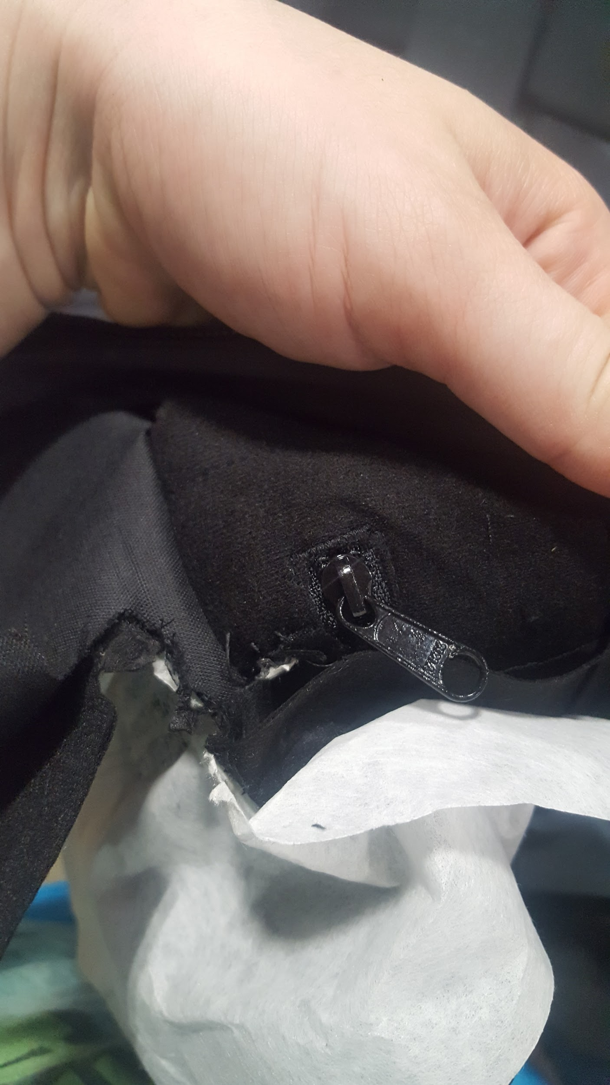

We’ve had a lot of nice jackets getting ruined lately that could be avoided with proper attention and care. You should automatically be checking the inside of the garment to see if there is a pocket in the way. If there is a way to embroider inside the pocket - go for it. If you will be sewing the pocket shut, stop production and consult the manager.

If the zipper is dangling near the embroidery, tape it down so it doesn’t accidently get in the way.

If the pocket is tight, clip the opening of the pocket to the frame so that it doesn’t get in the way and get sewn to the embroidery.

Sometimes the frame will not fit in the pocket. Stop production. Find alternative locations that we could embroider on and alert the manager to talk to the AM.



This Jacket is a two in one. That means there is an inner jacket zipped up into an outer jacket.

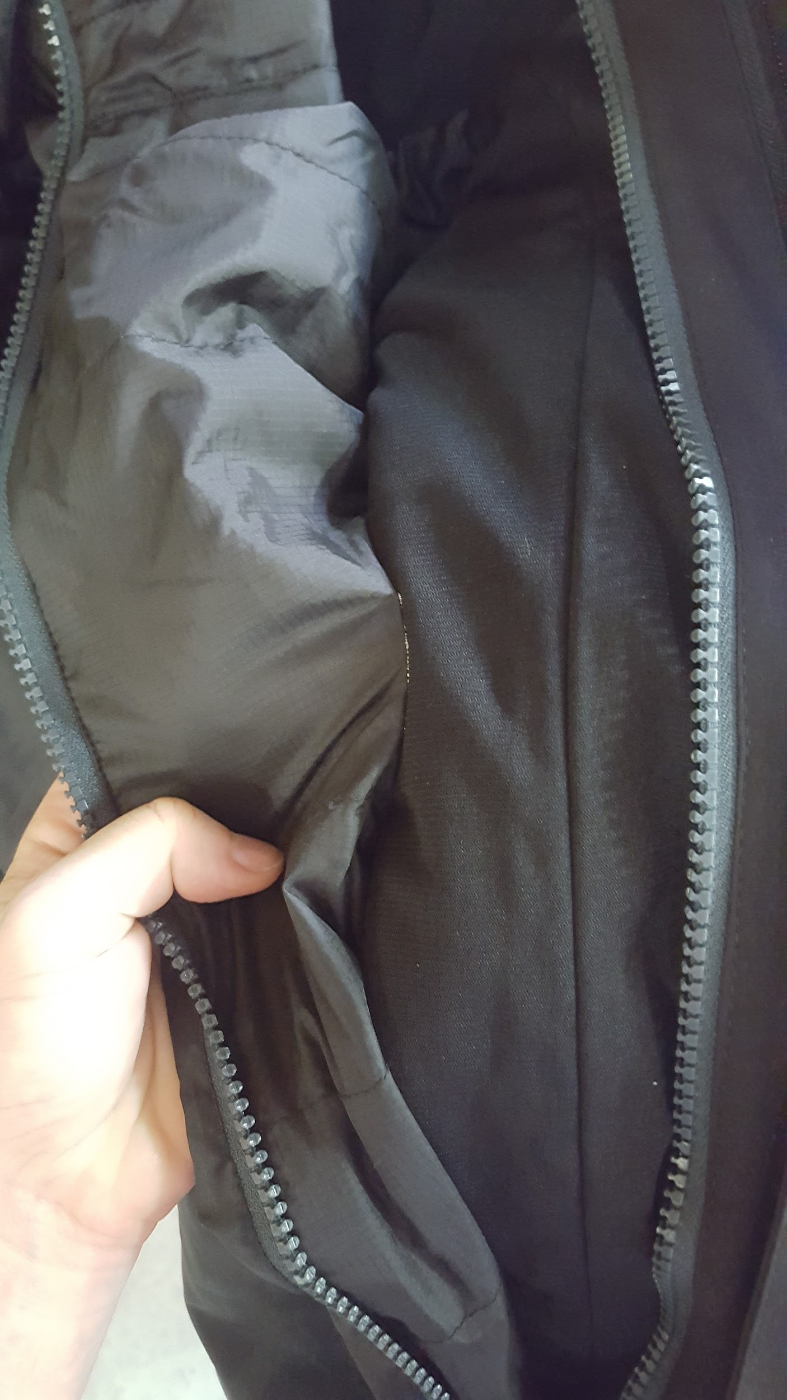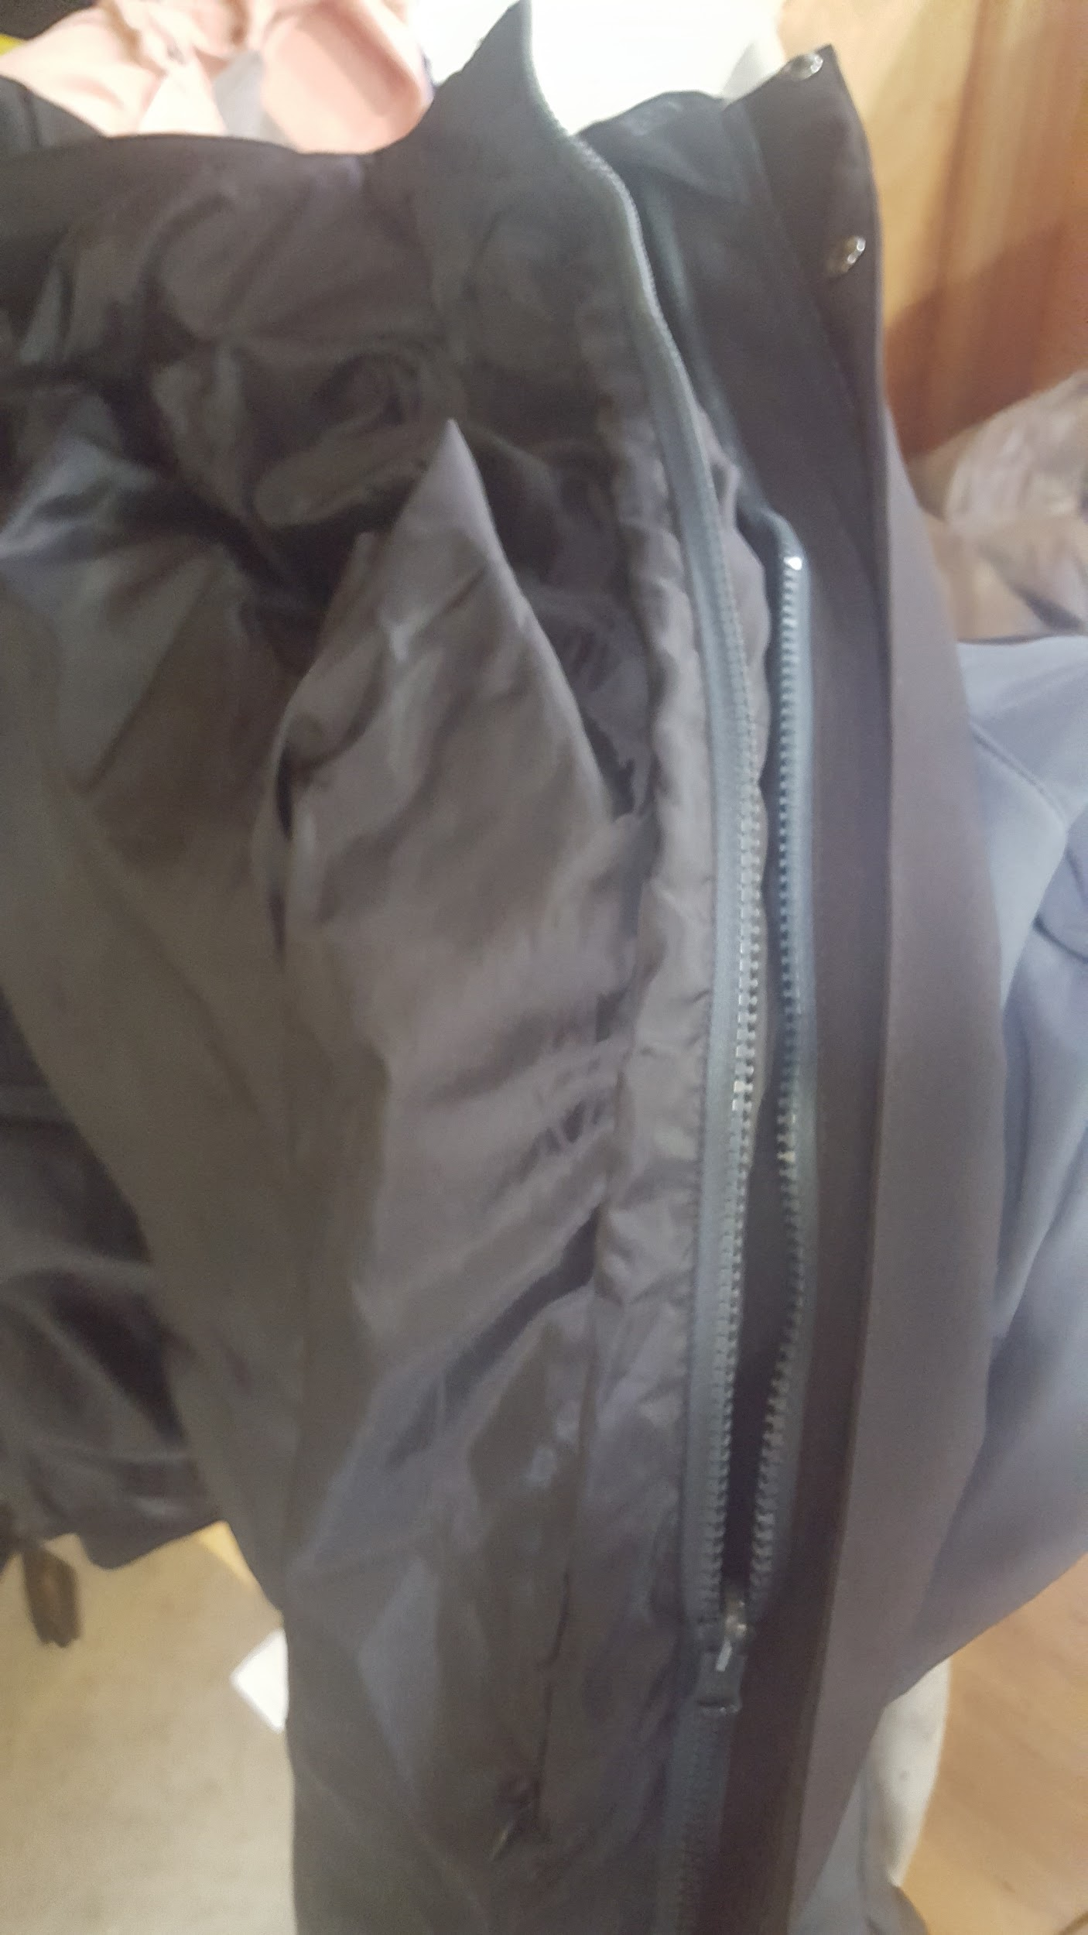

Do not sew the jackets together. Separate the jacket and only embroider the top shell with the embroidery.

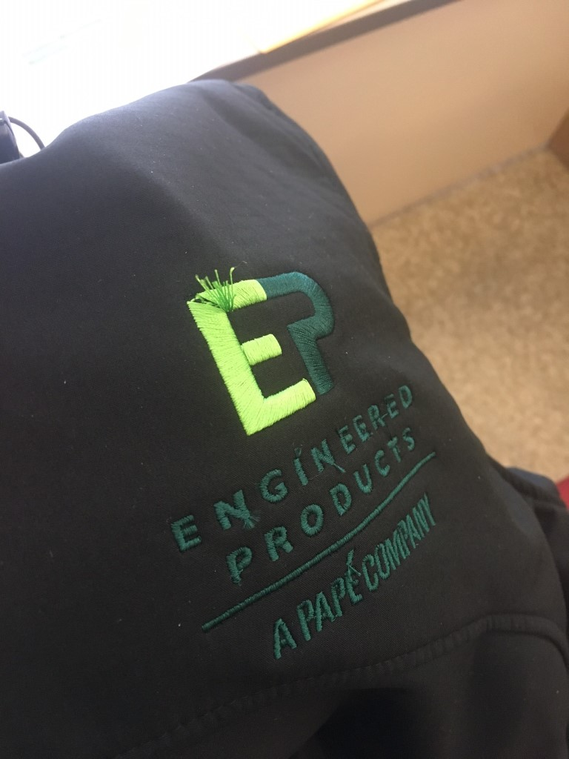

Rejected client piece.

\*This garment has fraying at key points. If there are stray threads we must trim them. IF there is a fray like on the top "E" we must reject the embroidery and not ship.

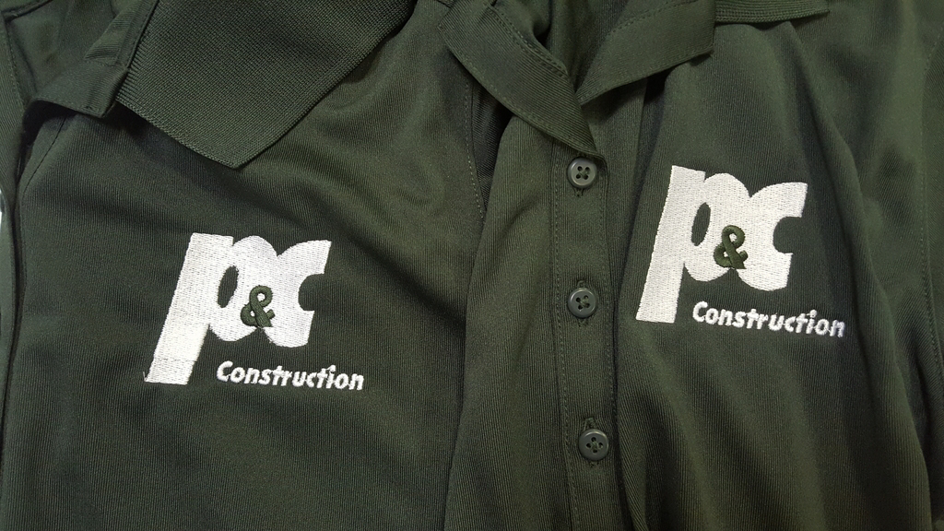

The mistake vs the standard

\*On the left the embroidery was overlapped twice as thick on the “P” This is unacceptable and needs to be filed as a misprint.

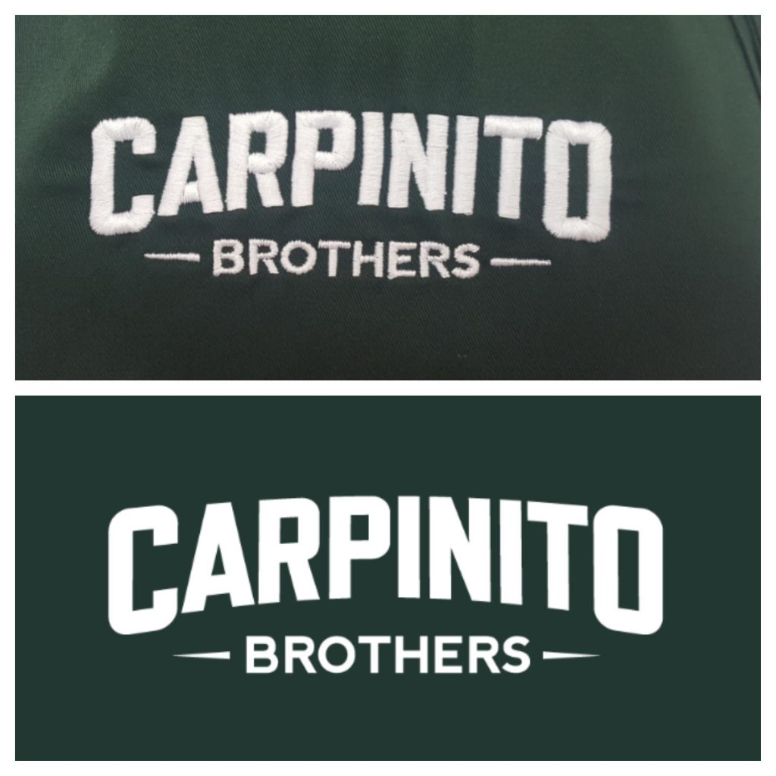

Top our embroidery vs bottom digital proof

\*Embroidery caused garment to pucker. We should explain to account manager that the tear away isn't stiff enough and allow them to choose between cut away and tear away on the back side of the garment. The client also was dissatisfied with the big “O” . If font looks wiggly, we should ask the digitizer for a fix. A woven backing might have also fixed the way the “O” pulls.\*

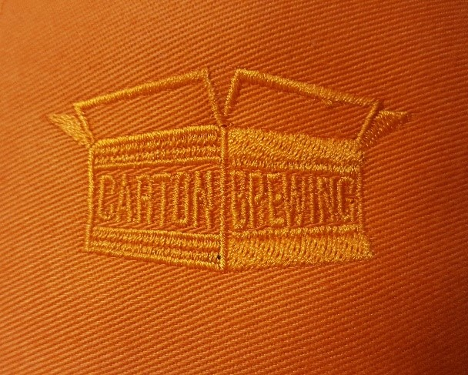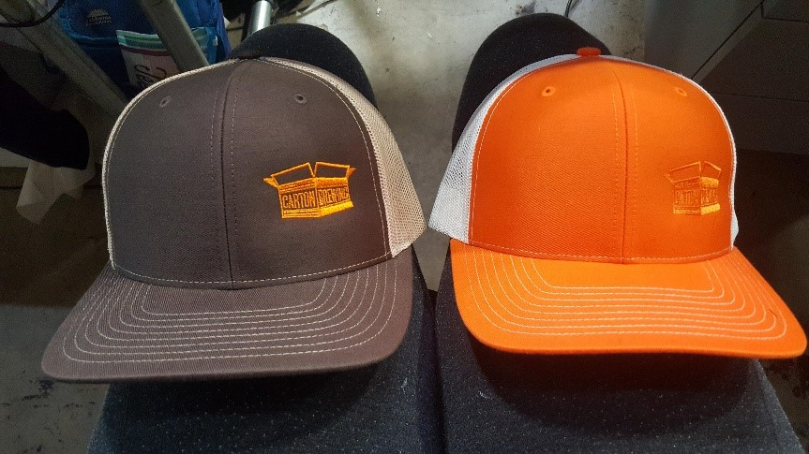

\*The client ended up rejecting the orange on orange hat because it was difficult to read. We must question their judgement and send a photo proof if branding is comprised by stylistic choices.\*

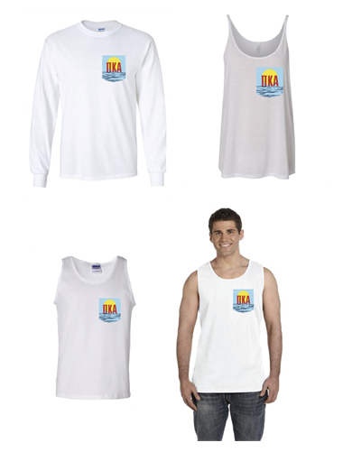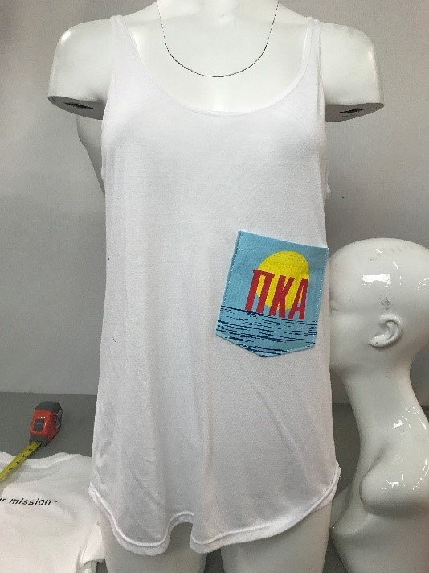

Digital Mock Up vs Crooked and low position

\*On women's tanks, it's better to make sure the hang of the garment doesn't affect the pockets position and that the pocket does not fall under the breast area.\*

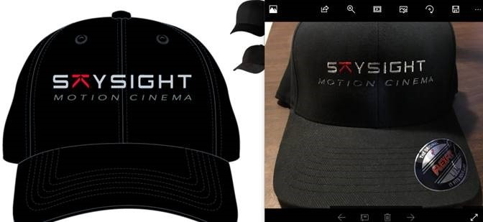

Digital Proof vs What we did

\* The issue is the client's branding requires the bottom text perfectly line up with the upper text. \*

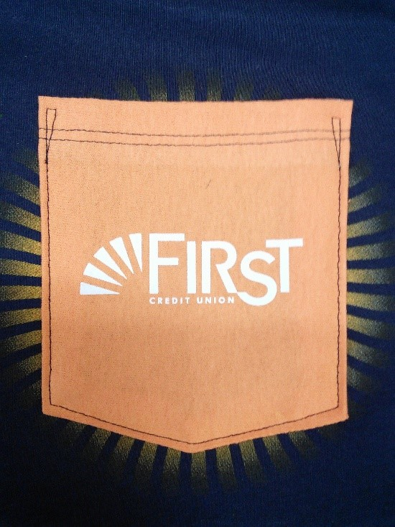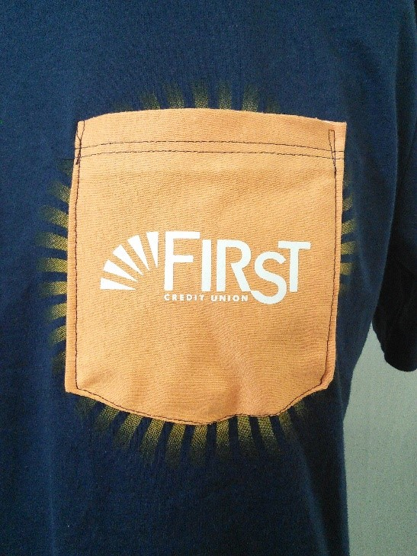

Good Pocket Application Vs Needs improvement pocket

\*When sending a photo proof, we want to send a beautiful example of our best quality work. Pocket stitching needs to look centered and not wobbly!\*

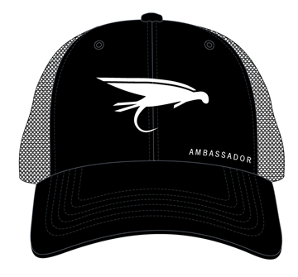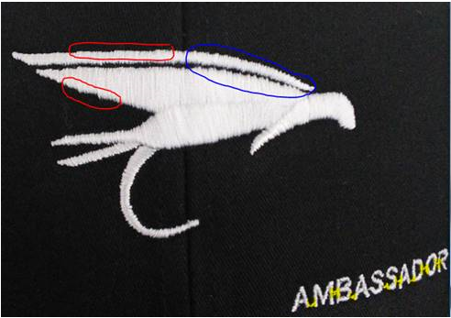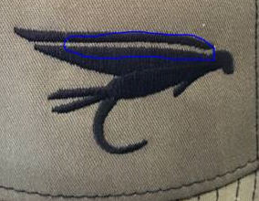

Top is Digital Proof. Bottom left is our proof. Bottom right is competitor's version from client.

\*Sometimes Client's expectations are just different. This client wanted smoother gradients in the rounding of the logo. Always feel free to suggest we send a photo proof if it is a complex design. In the text "AMBASSADOR" fine lines usually have a connecting embroidery stitch where we don't cut the thread from each one. If a client has an issue with it, ask the digitizer to update the file so each letter is separate.

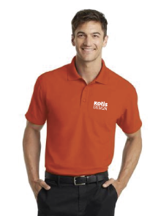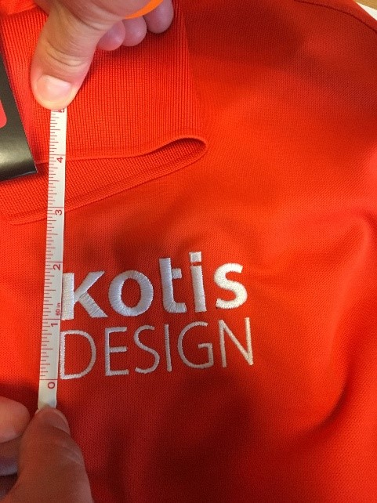

Digital Proof vs What we did

\* Technically the file matched the art call out, but the embroidery felt too large to the client. It’s ok to question how we can make it better if you have a gut check while working on it. \*

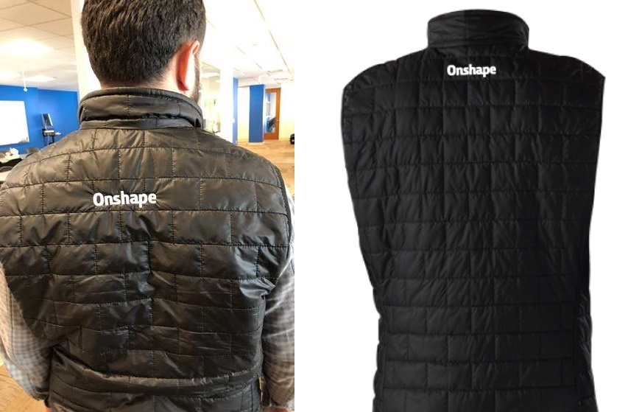

What we did vrs Digital Proof

Back tags should be 1.5 inches from collar seam. This is too low, does not match photoproof.

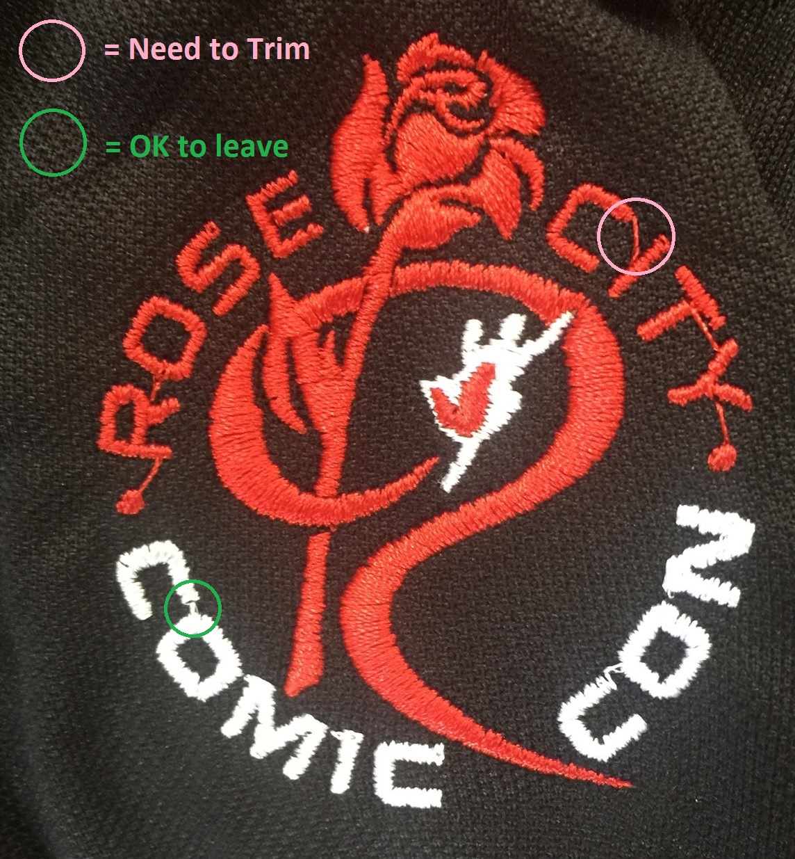

Some embroidery has a small jump between letters that is intentional and can be left. These are normally called running stitched. Sometimes embroidery has a larger thread called a jump stitch. Jump stitches should be trimmed in the cleaning process.